JAVA STRING HANDLING AND
COLLECTION FRAMEWORK
HIGHER-ORDER THINKING SKILLS

NAME:R.VARSHINI
REGNO:192525349

1)Evaluate whether exposing Iterator from an internal collection preserves encapsulation. Discuss modification risks andpropose safer alternatives.

AIM:

To demonstrate the importance of overriding both equals() and hashCode() methods when storing objects in a HashSet, and to observe how duplicate objects are handled when only equals() is overridden.

PROCEDURE:

- Import the java.util package.
- Create a Person class with an integer variable id.
- Create a constructor to initialize the id.
- Override the equals() method to compare two Person objects based on their id.
- Do not override the hashCode() method.
- Create a HashSet<Person> object.
- Add two Person objects with the same id value (1) into the HashSet.
- Print the size of the HashSet.
- Observe that the HashSet stores both objects because hashCode() is not overridden, even though equals() returns true.

JAVA CODE:

import java.util.*;

class Person {
int id;

Person(int id) {
this.id = id;
}

@Override
public booleanequals(Object obj) {
Person p = (Person) obj;
return this.id == p.id;
}
// hashCode() is NOT overridden
}

public class Main {
public static void main(String[] args) {
HashSet<Person> set = new HashSet<>();

set.add(new Person(1));
set.add(new Person(1));

System.out.println("HashSet Size = " + set.size());
}
}

OUTPUT:

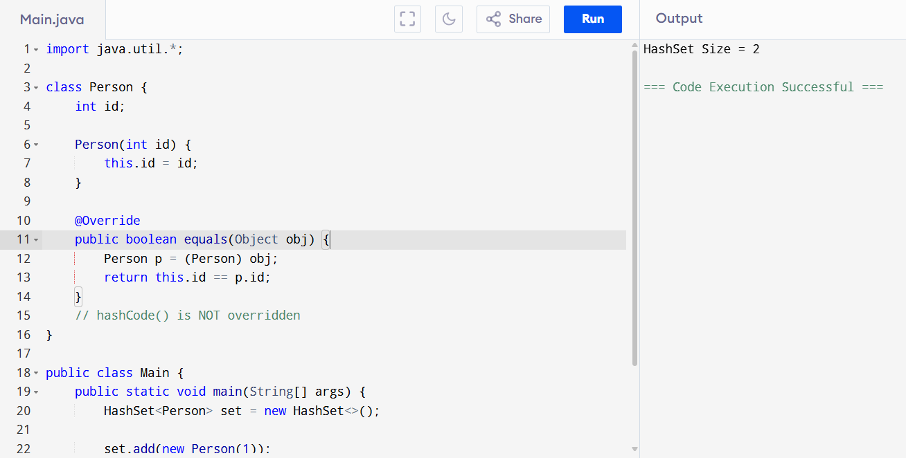

APPLICATIONS:
- Banking System
- E-Commerce Platform
- Library Management System
- Hospital Management System

